Self Evaluation Summary 2019/20

Unique Reference Number | 145224
DfE Number | 937/7047
Local Authority | Warwickshire
Type of School | Community Special
School Category | Academy
Date of summary record | September 2019 (updated March 2020)

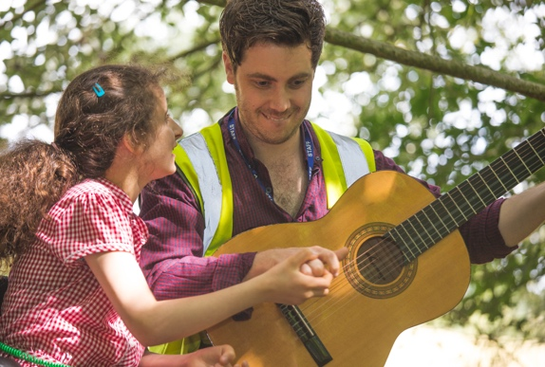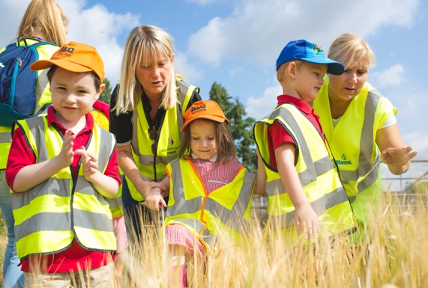

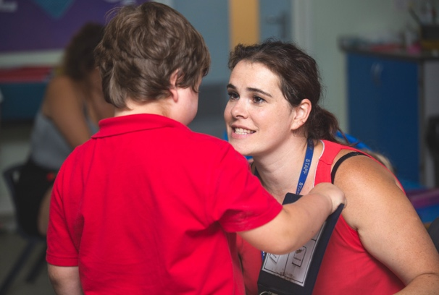

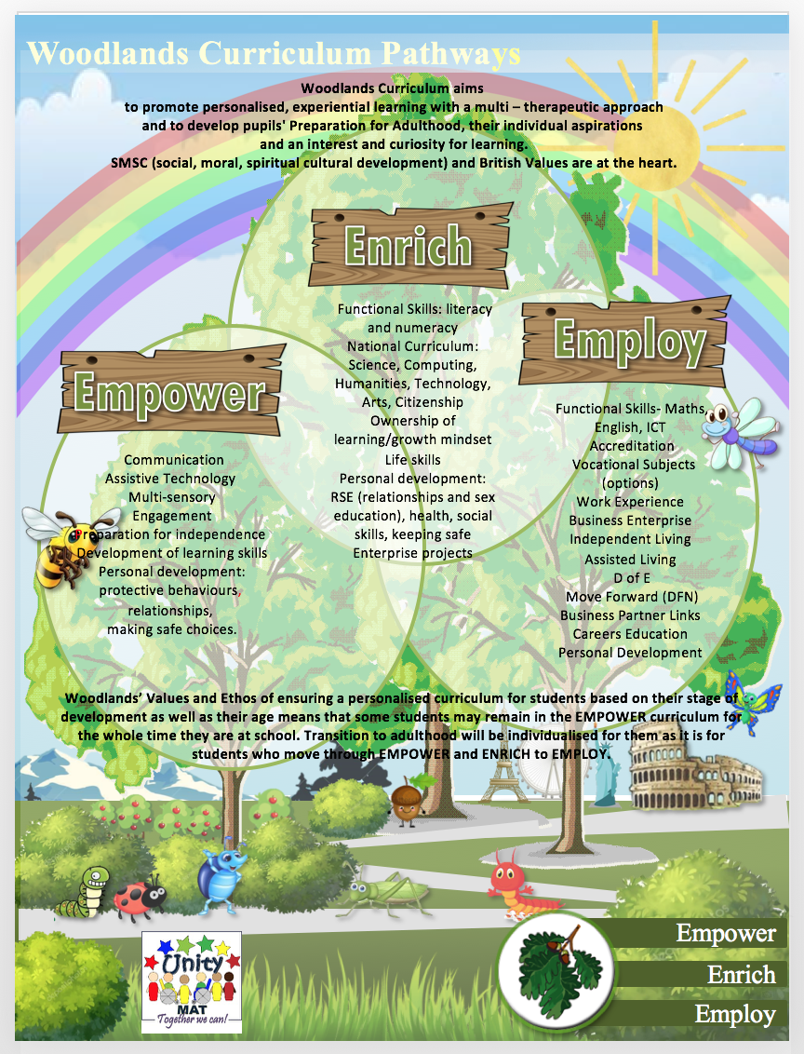

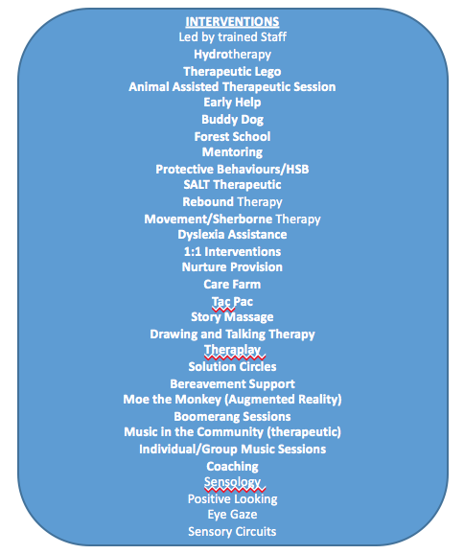

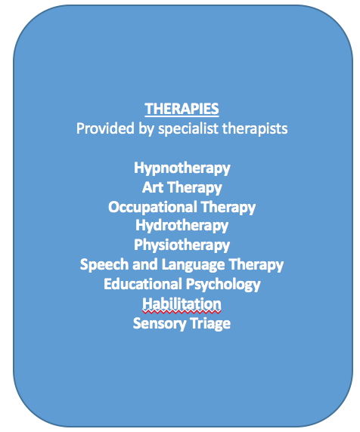

Quality of Education
 | Current Grade |  | 2
 | Last Inspection grade (2016) |  | 2
Main Strengths |  | Areas for Development
Intent  - Our curriculum consistently equips pupils for the next stages of their lives, and is destination-driven.  - Class teams are able to articulate about the progress made by children and students, and can identify accurately the next steps for learning.  - The majority of the curriculum is ambitious, broad and designed to give all pupils the knowledge and skills that they need to succeed.  - The extra-curriculum and multi-therapeutic provision are exceptional.  - Teachers have a strong and deepening knowledge of the subjects that they teach, including phonics/reading, writing and communication.  Implementation  - The majority of teachers, and teaching assistants, have good special needs knowledge & experience that is continually being refined through focussed CPD and weekly professional development meetings; this enthuses and challenges the vast majority of pupils and contributes to their at least good progress.  - The teaching environment is highly specialised, versatile and relentlessly designed to support learning.  - The provision is closely matched to the individual needs of the pupils, meaning that they are ready to learn and able to get the most from activities provided.  - There is relentless focus upon ensuring that pupils gain phonics, reading and communication skills, and the creation of strong foundations for future learning.  - In order to accelerate progress, teachers carefully select a range of effective styles and interventions to enhance learning.  - Teachers and leaders use assessment well, for example to help pupils embed and apply new skills, or to check understanding and inform practice. Leaders understand the limitations of assessment and do not use it in a way that creates unnecessary burdens for staff or pupils.  Impact  - There is a high percentage of at least Good learning characterised by clear focus on developing new skills, whilst accurately overcoming barriers to learning.  - Pupils have well documented progress over time that underpins their consistently at least good termly progress.  - Pupils are very well prepared for the next stage of education, employment or training. They have the knowledge and skills that they need and, where relevant, they gain qualifications that allow them to go on to destinations that meet their interests and aspirations and the intention of their highly individualised curriculum. |  | - Whilst progress is at least good, target setting/next steps in some parts of the school needs to be more aspirational, holistic and consistently bespoke/relevant to achieve greater outcomes.  - More consistent awareness of the learning purpose of all activities.  - Whilst teaching teams have a strong understanding of individual needs, more staff need to have stronger areas of specialist knowledge so they can effectively develop the knowledge of all learners.  - Ensure that Woodlands environment and curricular delivery consistently empowers communication and access for all learners.
Behaviour and Attitudes
 | Current Grade |  | 1
 | Last Inspection grade (2016) |  | 2
Main Strengths |  | Areas for Development
- Pupils are happy and enjoy school. The clear majority of pupils' behaviour is good to outstanding - evidenced through consistently thoughtful behaviour towards one another, towards staff and towards visitors in and out of the classroom context. This is intrinsically linked to the positive school ethos: relationships in the school are warm and based on mutual respect. There is a strong family atmosphere.  - Pupils consistently have highly positive attitudes and commitment to their education. They are highly motivated and persistent in the face of difficulties. Pupils make a highly positive, tangible contribution to the life of the school and/or wider community.  - The school has a clear, effective and regular reviewed behaviour policy which underpins and is reflected in school practice and provision.  - Pupils speak positively about the school and the range of opportunities that are provided for them, such as the farm, regional sports competitions and business enterprise. Older students can clearly articulate what they want to do for their next steps and are well supported to achieve these destinations.  - All leavers enter further education or training, with a developing number entering straight into employment.  - Where behaviour is not outstanding, the class team is accurately able to adjust the provision to ensure strong outcomes.  - Behaviour for the vast majority of pupils around the school is outstanding, due to the high expectations set by the governors, staff and parents.  - Teachers’ and teaching assistants outstanding management of behaviour results in learners that are self-confident, keen to do well and able to thrive and learn in an atmosphere of respect and dignity.  - The school’s ability to promote equality and tackle all forms of bullying and harassment is outstanding, placing these issues at the heart of all its work. These aspirations are understood and acted upon consistently at all levels.  - The school has good levels of attendance. Attendance is promoted through regular monitoring and relentless actions from leaders and the Pastoral Team.  - Fixed term exclusions are extremely rare.  - Constant analyses of behavioural communications ensure rapid and evolving interventions. |  | - Further development of an environment that empowers pupil self-regulation, personalisation and well-being through universally consistent implementation of the Behaviour & Relationships Policy.  - Ensure the environment is increasingly versatile and designed to promote well-being and self-regulation.  - Increased monitoring and multi-agency collaboration to increase attendance of persistent pupil absentees.
Personal Development
 | Current Grade |  | 1
 | Last Inspection grade (2016) |  | 2
Main Strengths |  | Areas for Development
- Woodlands consistently promotes the extensive personal development of pupils. The school goes significantly beyond the expected, so that pupils have access to a wide, rich set of experiences.  - Woodlands provides these experiences in a coherently planned way, in the curriculum, through extra-curricular activities, and an exceptional range of therapies and interventions.  - The way Woodlands goes about developing pupils’ character, self-advocacy and well-being is trail-blazing.  - Woodlands provides high quality and highly responsive pastoral support.  - Woodlands provides pupils with meaningful opportunities to to understand how to be responsible, respectful, active citizens who contribute positively to society.  - Safeguarding is an outstanding strength of the school. Pupils feel safe in school, and staff and parents & carers agree.  - A strong culture of care and support exists across the school. Pupils’ welfare is given a high priority by all staff. Work with external agencies is exceptional.  - Pupils are prepared exceptionally well for the next stages of their lives through personalised, versatile and aspirational pathways.  - Pupil Voice is relentlessly promoted through surveys, leadership roles and a school-wide focus upon empowerment through communication.  - RSE interventions are carefully tailored to need and circumstance. |  | - Further evolve Outdoor Learning opportunities and the rigour and aspiration of delivery.  - Pupil well-being relentlessly enhanced through focus upon PSHE, Protective Behaviours and mental health and through continual review of impact.  - Greater consistency of preparation of pupils for the next stage of their lives through universally bespoke, progress and relevant assessment, streamlined and accessible target setting and tracking and continued evolution of a skills-based curriculum.  - SMSC/British Values further embedded through evolution of curriculum, assemblies, workshops and immersive days.
Effectiveness of Early Years Provision
 | Current Grade |  | 2
 | Last Inspection grade (2016) |  | 2
Main Strengths |  | Areas for Development
- Teachers and support staff are highly skilled. They know their pupils exceptionally well and have high expectations of them. As a result, the clear majority of pupils make strong and sustained progress – both in their learning and in their personal development.  - Pupils demonstrate their positive attitudes to learning through high levels of curiosity and engagement.  - Outdoor and indoor areas are used increasingly effectively and creatively to provide a rich range of learning experiences. Planning for extension activities has increased.  - Pupils’ behavioural communications are exceptionally well managed and evolved. A strong and responsive infrastructure of multi-agency support, therapies and interventions is used effectively to aid the development of personal and social skills.  - Consequently, pupils are empowered to begin to manage their own feelings and behaviour, and to understand how these may impact upon others.  - Assessments are used exceptionally well to inform next steps and practice. This “assessment for learning” has been held up as a model of excellent practice by the School Improvement Partner.  - Staff involve parents closely with updates re their children’s progress.  - Curriculum and care practices promote and support children’s emotional security and personal development.  - There is a sharp and relentless focus upon the development of communication and independence skills.  - SLT and the Middle Leader have constructed a curriculum that is ambitious and designed to challenge and engage pupils. |  | - Diversity and clarity of function of different areas of environment to be enhanced to further empower pupil progress and curricular delivery.  - Environment and practice consistently empower communication and learning.  - Pupils for whom self-regulation and communication are the foci to be placed within a more relevant, bespoke and progressive assessment framework.
Effectiveness of Sixth Form Provision
 | Current Grade |  | 2
 | Last Inspection grade (2016) |  | 2
Main Strengths |  | Areas for Development
- Leadership focuses on helping the clear majority of pupils to make at least Good progress in their learning, development and welfare.  - The provision for post-16 students, while always being a strength of the school, is improving further still.  - The school has worked hard over the past four years to broaden the opportunities for work experience. The staff know each of the pupils extremely well and identify programmes of work and access to courses which build on the pupils’ individual interests and abilities. As a result, the pupils work hard and are impressively well-prepared for the next stage of their training, education or work. The school has established ambitious and successful links with local businesses and industry.  - For the clear majority of pupils in post 16-19 provision, progress is strong in Independence Skills, accreditation and soft skills.  - Most teachers, and teaching assistants, have good special needs knowledge & experience which is continually being refined through focussed CPD and weekly professional development meetings; this enthuses and challenges most students and contributes to their outstanding progress.  - Students behaviour whilst on work placements or on community-based learning is outstanding, which is evidenced well through community voice.  - Leadership of post-16 provision is strong. Staff work tirelessly to maximise students’ life-chances. Locally developed facilities, industry links and work experience opportunities are exceptionally strong. The curriculum is dynamic and rooted in real life.  - Students’ behaviour is exemplary. They value their education, though the attendance of a small minority needs to improve.  - Students take on roles and responsibilities and support the life of the school and local community.  - The majority of curricular delivery is aspirational and well planned. Leaders and staff are aware of the areas that need improvement within the Enrich curriculum, and are moving swiftly to address these. |  | - Ensure consistency of level of rigour and aspiration of all elements of the curricula.  - Ensure that assessment of progress is universally relevant, and that it empowers next steps and informs evolution of practice.  - Ensure that preparation of pupils for the next stage of their lives is universally bespoke, ambitious and relevant.
Leadership & Management
 | Current Grade |  | 2
 | Last Inspection grade (2016) |  | 2
Main Strengths |  | Areas for Development
- Leaders and Governors provide strong leadership. They have created a culture of relentless ambition and focus upon enhancing pupils’ life-chances.  - Senior leaders and Governors have an accurate understanding of the school’s effectiveness.  - The curriculum is innovative, empowering and highly personalised. Leaders are constantly reviewing the curriculum to ensure that it meets pupils’ changing needs. Consequently, pupils are well prepared for the next stage of their education.  - H & S and site management systems are extremely strong.  - Leadership of safeguarding is exceptionally strong. The holistic approach taken by the school in this aspect of its work is highly effective. A blend of Medical, SLT and Pastoral staff ensures an outstanding level of insight, multi-agency liaison and parental engagement.  - Leaders are tenacious in following up concerns with the LA and other agencies.  - Through the curriculum, workshops and assemblies, pupils are taught about e-safety, Protective Behaviours, relationships and self-care.  - SLT and Governors value the contribution that staff make to school. They provide effective support for staff’s well-being and workload. Staff value this support and their morale is high.  - SLT and Middle Leaders thoroughly analyse a diverse range of assessment information to effectively identify where intervention is needed. As a result, the clear majority of pupils are making substantial and sustained progress.  - The school’s curriculum is swiftly emerging as a particular strength. Leaders continually review the curriculum to ensure that it is progressive, aspirational, creative and personalised.  - The school has strong links with the LA and industries. The school is recognised, by the LA, as a model of excellent practice, and as being “destination-driven”.  - Topic based work and immersive days effectively contribute to the promotion of pupils’ spiritual, moral, social and cultural development and, within this, the promotion of British Values.  - Additional funding, including the Pupil Premium, Year 7 Catch-up Funding and PE & Sports Funding, is used carefully and effectively. The spending takes full account of the needs of individual pupils and is well-targeted. There are no discernible differences in outcomes for different groups. The PE & Sports Premium is used well and encourages pupils to participate in an exceptional range of opportunities. |  | - Retain, attract and develop the best teachers and future Middle Leaders.  - Staff well-being relentlessly enhanced.  - Reduction of teacher workload emancipates teachers to focus more exclusively upon delivery of the curriculum and enhancement of learning.  - CPD programme further developed that is consistently that is versatile, progressive and responsive.  - Governance: Governors scale of input celebrated and monitored – “out of the board room, into the classroom”.

